Renaissance Progress Monitoring Directions
 | Log in to clever on the computer or ipad.
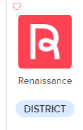  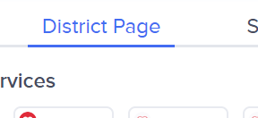 | Click on the district page  Select Renaissance
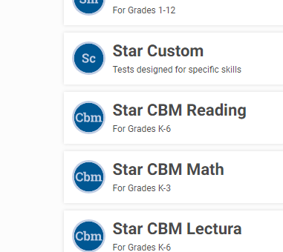 | Click on Star CBM Reading  Record book and assessment
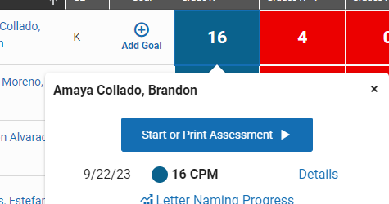 | Click on the probe (color) next to the child’s name  Press start or print assessment
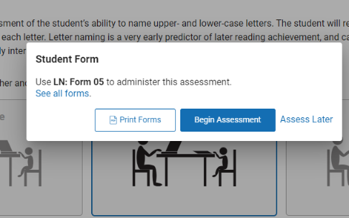 | Select mixed format  Select begin assessment
 | Open up the probe directed to you- have the student look on with the probe and you will mark on the iPad.

